**Mendham Township Middle School**

# 16 Washington Valley Road, Brookside, NJ 07926

# Patrick J. Ciccone, Ed.D Telephone 973-543-7107

*Principal*  Fax 973-543-0701 *pciccone@mendhamtwp.org*

August 13, 2018

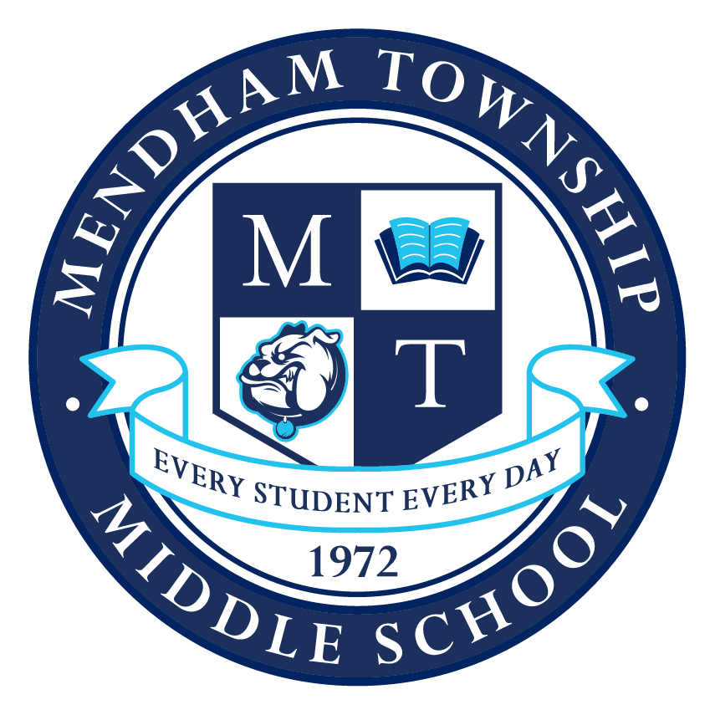**Welcome Back 2018-2019**

Dear Mendham Township Middle School Family,

Welcome back to the 2018-2019 school year at MTMS. It is my sincere hope that your children thrive in our academically challenging environment and participate in numerous athletic, music, art, and theater related activities. If you feel your child is not thriving, please contact his/her teacher, the School Counselor, and or me. We can assign your child to a multitude of available supplemental classes either before school or during enrichment periods – as well as help him/her find some school based activities to round out the day and make connections to our school.

Superior customer service is paramount to the success of our students and to a smooth and successful transition back to school. Please, call or email me if you feel we can do something better than we are doing it now! If you have questions, call the front office or email me directly – we are here to help and enjoy doing so! When parents are comfortable, supportive, and tuned into a transparent system of education, together we can maximize the potential that every student will learn to his/her greatest potential every day. Every Student Every Day!

A link to all of the documents below was emailed to parents on 8/3/17 and is available online at the [new school web page](http://mendhamtwporg.finalsite.com/middle-school-home) in the [“About”](https://mendhamtwporg.finalsite.com/middle-school-home/about-mtms) section under [“Welcome Back Documents”](http://mendhamtwporg.finalsite.com/middle-school-home/about-mtms/welcome-back-documents) .

* [2018-19 District Health Emergency Card](https://www.mendhamtwp.org/uploaded/FORM_M_2_Health_Emergency_Card_2018-19.pdf) (FORM M-2)   
  Return by SEPTEMBER 15 - NO EXCEPTIONS
* [2018-19 Consent for Publicity](https://www.mendhamtwp.org/uploaded/FORM_M_8_Consent_to_Print_2018-19.pdf) (FORM M-8)  
  Return by SEPTEMBER 15 - NO EXCEPTIONS
* [2018-19 Concussion/Head Injury Information](https://www.mendhamtwp.org/uploaded/FORM_M_4_Concussion_sign_off_sheet.pdf) (FORM M-4)   
  Return by SEPTEMBER 15 - NO EXCEPTIONS
* [2018-19 6th grade (ONLY) Immunization Letter/Vaccine Table (physician to complete)](https://www.mendhamtwp.org/uploaded/FORM_M_9_2018_6th_Grade_Mandated_Vaccine_Letter.pdf) (FORM M-9) Return by SEPTEMBER 15 - NO EXCEPTIONS
* [2018-19 Science Opt Out Letter](https://www.mendhamtwp.org/uploaded/Opt_Out_Science_2018.doc) (FORM M-11)
* [Sudden Cardiac Death in Young Athletes](https://www.mendhamtwp.org/uploaded/FORM_A_5_Cardiac_Arrest.pdf) (FORM A-5)
* 2018-19 Picture Day Order Form (picture day is Wednesday, September 13, 2018)
* 2018-19 Free and Reduced Lunch Letter (FORM M 10) (to be completed as needed)
* [The complete MTMS 2018-2019 calendar](https://mendhamtwporg.finalsite.com/middle-school-home/calendar);
* [Homework Posting Guideline (all grades)](https://mendhamtwporg.finalsite.com/fs/pages/369):
* [Fifth / Sixth Grade Homework Guidelines](https://mendhamtwporg.finalsite.com/middle-school-home/academics/grade-5-6-homework-guidelines); and
* Recommended 2018-2019 School Supply Lists; ([fifth](https://mendhamtwporg.finalsite.com/uploaded/5th_gr._school_supplies_18-19.pdf) / [sixth](https://mendhamtwporg.finalsite.com/uploaded/6th_gr._school_supplies_18-19.pdf) / [seventh](https://mendhamtwporg.finalsite.com/uploaded/7th_gr._school_supplies_18-19.pdf) / [eighth](http://mendhamtwporg.finalsite.com/uploaded/17-18_TOOLBOX-8.pdf))

All of this information and an overview of new staff to MTMS are located on the school’s [welcome back area](https://www.mendhamtwp.org/middle-school-home/about-mtms/welcome-back-documents) of the [web page](https://mendhamtwporg.finalsite.com/middle-school-home).

Good Luck and Have a Great 2018-2019 School Year!

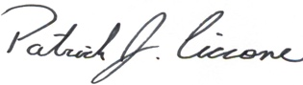

**Please take some time to review the following items with your children:**

**EMERGENCY CARDS / CONCUSSION FACT SHEETS**

In order to most efficiently safeguard all of the students at MTMS, it is crucial that we have completed emergency information for every student which includes: a **Student Emergency Card**, a **Concussion & Head Injury Fact Sheet** and a **Consent For Publicity Form**. All three documents must be completed and returned no later than **September 7, 2018**. Students will not be permitted into class on September 11 if the office does not have all three completed documents in our possession. The emergency card is a critical document for keeping our children safe and parents informed in case of emergency. Please get them in as soon as possible.

**SAFETY PROCEDURES**

1. Non-emergency items including lunches, athletic equipment, and schoolwork shall not be dropped off by parents between the hours of 8:05 am and 3:05 pm, as non-emergency items will not be delivered to students during the school day. The school will provide “I owe you” lunch vouchers for students who forget their lunches. There will be a “drop off grace period” between 9 am and 10 am.

2. Stopping or Standing (parking) in the circle directly in front of the school is prohibited between the hours of 8:05 am and 3:05 pm. Visitors to the school who park in the circle will be required to move their vehicles prior to entering the building.

**ONCOURSE PARENT & HOMEWORK PORTAL**

All homework assignments are posted online on and accessible to parents and students via the Academics tab on our web page, [Homework Calendars and Posting Guidelines](https://mendhamtwporg.finalsite.com/middle-school-home/academics/homework-calendars-posting-guidelines) .

By logging in to our [Oncourse Parent Portal](https://www.oncourseconnect.com/account/login) program, all MTMS parents will have on-demand access to their child’s most recent and cumulative Mathematics, Science, Social Studies, World Language, and Language Arts grades. Homework completion for each week will be updated every Friday. Tests, quizzes, essays, and other graded projects will be posted to the portal immediately after the teacher completes the grading process. Note that lengthy assignments, exams, projects, and essays might take up to a week to post to the portal. Parents also have on-demand access to student attendance and tardy records. Need help? Call the front office 973-543-7107. All students earning a mid-term grade of less than a 79.5% will have a paper mid-term progress report sent home automatically. All end of marking period grades will be available electronically and will not be mailed home.

**CODE OF CONDUCT – MTMS HANDBOOK**

The 2018-2019 [**Mendham Township Middle School Handbook**](https://mendhamtwporg.finalsite.com/middle-school-home/about-mtms/code-of-conductstudent-handbook) / [Code of Conduct](https://mendhamtwporg.finalsite.com/middle-school-home/about-mtms/code-of-conductstudent-handbook) / Anti-Bullying Policies were emailed to all MTMS parents via the Honeywell notification system on 8/8/18. Please take some time prior to the start of the new school year to review its contents with your child. In addition, please know that it is also available online on the [Middle School Home Web Page](http://mendhamtwporg.finalsite.com/middle-school-home). If you would like to request a paper copy please contact the main office.

**Two quick notes:**

1. **If a teacher needs to remove a student from a classroom at any time, for any reason, the student shall notify his/her parent via telephone that he/she will serve a 2-day afterschool detention (at minimum).**
2. **If a student is caught cheating in any capacity, he/she will earn a 0% on the assignment for the first offense and parents will be notified. The second offense will also earn a 0% with additional ramifications delineated by the code of conduct guidelines (i.e. detentions, suspension, removal from trips etc.).**

**COMMUNICATION WITH TEACHERS / STAFF**

If at any time, you have questions or concerns regarding your child’s progress, you are highly encouraged to contact our teachers via the main office telephone number or email. A [staff contact information page](https://mendhamtwporg.finalsite.com/middle-school-home/about-mtms/staff-directory) is located on the school’s web page. Please note that as a general rule, all MTMS staff members will respond to parent phone calls, messages, and or e-mails within 24 hours of receipt. If repeated attempts to contact a staff member do not result in a timely response, please contact the front office, as the contact information may be incorrect. [MTMS Administration](http://mendhamtwporg.finalsite.com/middle-school-home/about-mtms/administration) will return phone calls and or e-mails prior to the day’s end.

**HARASSMENT / INTIMIDATION / BULLYING (HIB)**

**Mendham Township Middle School continues a campaign to eliminate harassment, intimidation, and bullying from our school community.** Each grade level reads a novel in language arts class, in which the main character is exposed to bullying. Through the teaching of these novels, our language arts staff will focus discussion not only on preventing bullying, but also on providing coping strategies for students who are bullied or feel like ‘an outsider’.

[Policy 5512](https://mendhamtwporg.finalsite.com/uploaded/5512-_HARASSMENT_INTIMIDATION_AND_BULLYING_-M.pdf) (Harassment/Intimidation/Bullying - HIB), [Policy 5512](https://mendhamtwporg.finalsite.com/uploaded/5512_R.pdf) (HIB Investigation Procedures) and [Policy 5600](https://mendhamtwporg.finalsite.com/uploaded/5600.pdf) (Conduct and Discipline) are located in the “Programs” tab along the top of our web page under “[*Anti-Bullying Policy / Procedures*](https://mendhamtwporg.finalsite.com/middle-school-home/programs/anti-bullying-policies-procedures).” An [electronic / anonymous bullying incident reporting instrument](https://docs.google.com/forms/d/e/1FAIpQLSfJVObR7C7ODHZv0jIVEnB6TkAoiSo9kxLqwu5KdNfBWxO_kw/viewform) is also available on the same webpage. You can always call the school’s anti-bullying specialist, Ms. Perrotta at 973-543-7107, to report an incident of HIB policy violation.

Along with a thorough investigation, the text on page 4 of this letter constitutes the litmus test that the building principal and the anti-bullying specialist utilize to determine whether an ‘incident’ violates the District’s HIB Policy.

Most bullying behaviors are delineated in Policy 5600 as “Level 3” infractions andimpose a response that will effect a change in behavior through, but not limited to, at least a one day out-of-school suspension. Students who retaliate against students who report incidents of bullying / harassment / intimidation are subject to escalated consequences set forth in Policy 5600.

In early September, [Ms. Perrotta, our School Counselor](https://mendhamtwporg.finalsite.com/middle-school-home/programs/school-counselor), will facilitate presentations to each grade level to ensure that all students understand their behavioral obligations, the specific actions that constitute bullying / harassment / intimidation, and the expected consequences for bullying / harassment / intimidation. Ms. Perrotta will include information regarding the specific violations requiring notification to the Mendham Township Police Department (ie… harassing or threatening behaviors away from school, via digital mediums, and or at school).



**WELFARE CHECKS**

Our first and most important morning responsibility is to account for every student! In this regard, please remember that it is mandatory to inform the office by no later than 8:00 am if your child is not going to be in homeroom by 8:10 am. Whether your child will be absent for the day, or a few minutes late, it is extremely important that you notify the main office. Parents may leave messages in the general delivery mailbox at any time to report student absences or tardiness. After calling all persons listed on your emergency card, if we are unable to locate your child, a **Student Welfare Check** will be performed by the Mendham Township Police Department.

**CELL PHONE & ELECTRONIC DEVICES (ED) PRIVILEGES**

MTMS students are permitted to bring cell phones and EDs to school under the following conditions:

1. Cell phones / EDs must **remain off** from 8:05 am until 2:50 pm.

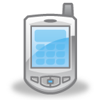 2. Cell phones / EDs will be confiscated if powered on and or in use …on first offense.

3. Confiscated cell phones / EDs will be returned only to a parent / guardian.

4. Third confiscation warrants permanent loss of cell phone / ED privileges.

5. Using a cell phone / ED to bully, harass, intimidate, or spread ‘rumors’ about another student shall result in permanent loss of cell phone privileges and the police may be notified.

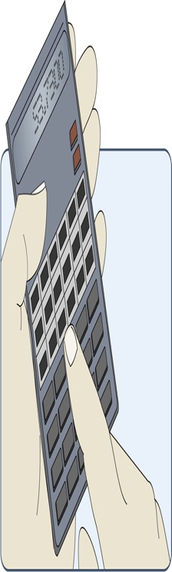**2019 - 2020 Mathematics Placement / Eligibility Requirements**

It is extremely important that students (and their parents) understand the [eligibility requirements](https://mendhamtwporg.finalsite.com/middle-school-home/academics/advanced-math-placement), expectations, and process utilized to determine mathematics placements so that they may present a concerted effort to pursue an accelerated math course if desired. The Oncourse Parent Portal will assist in this regard. All eligibility questions should be directed to Dr. Ciccone. Please review the following placement guidelines:

**2018-2019 Fifth and Sixth Graders:** All students in fifth and sixth grades will participate in mathematics placement tests in May, 2019, to determine eligibility for accelerated mathematics in 2019-2020. A performance matrix including placement test results, teacher recommendations, and ‘end-of-year’ mathematics grades will be utilized to determine eligibility into accelerated mathematics in grades 6 (one section) and 7 (two sections). All accelerated and non-accelerated sections are heterogeneously grouped.

**2018-2019 Seventh Graders:** At this point in time, **it appears** we will be facilitating two sections of Grade 8 Math and three sections of Honors Algebra 1 in the 2019-2020 school year. The following criteria will be used to determine 8th grade mathematics placement;

***- Who is eligible for Honors Algebra 1?***

1. Students who are currently taking Accelerated Math 7 AND earn a ‘year-end math average’ **greater than or equal to** 79.5%.

2. Students who are currently taking Math 7 and earn a ‘year-end math average’ **greater than or equal to** 93.5%.

***- Who is eligible for Grade 8 Math?***

1. Students who are currently taking Accelerated Math 7 who earn ‘year- end math average’ **below** 79.5%.

2. Students who are currently taking Math 7 and earn a ‘year-end math average’ **below** 93.5%.

**SUBJECT TO INSPECTION**

***“All lockers and desks are school property and therefore, are subject to inspection (***[***18A:36-19.2***](http://law.justia.com/codes/new-jersey/2016/title-18a/section-18a-36-19.2/)***.) by school administration if the school official has reasonable suspicion of concealed contraband.”*** The preceding statement will be read during morning announcements for the first 8 days of school. If inspection reveals illegal contraband / weapons / drugs, the student’s parents and the Mendham Township Police Department will be immediately notified. This is the warning and there shall be no exceptions.

We highly discourage students from bringing expensive electronic devices to school as they are often lost or damaged. The school is not responsible for the safe return of these devices; especially if stored in unlocked lockers. If you choose to send your child to school with an electronic device or any other valuables, it may be worthwhile to utilize a lock on your child’s locker so that their belongings are secure. All lock combinations must be provided to the front office on the day the lock is in use.

**ZERO PERIOD**

1. **Performing Arts:** [**Band**](https://mendhamtwporg.finalsite.com/middle-school-home/activities/band) **/** [**Orchestra**](https://mendhamtwporg.finalsite.com/middle-school-home/activities/orchestra) **/** [**Chorus**](https://mendhamtwporg.finalsite.com/middle-school-home/activities/chous)

All grade 6 – 8 zero period classes will begin on Thursday, August 27, 2018, as delineated on your child’s zero period bus pass. Grade 5 zero period Orchestra will begin September 27 and Grade 5 zero period Band on September 28. This year we have added Jazz Band and Lab Band to our offerings. The schedule of classes is listed below:

|  |  |  |  |  |
| --- | --- | --- | --- | --- |
| **MONDAY** | **TUESDAY** | **WEDNESDAY** | **THURSDAY** | **FRIDAY** |
| Wind Ensemble | Jazz Band  Concert Band | Lab Band  Wind Ensemble | Concert Band | Jazz Band  Blue Band  (Grade 5 Band) |
| Orchestra Grades 6-8 | -------------- | Orchestra Grades 6-8 | Orchestra Grade 5 | ---------- |
| -------------- | Chorus Grade 7&8 | Chorus Grade 6 | Chorus Grade 7 & 8 | Chorus Grade 6 |

You **must** leave a message at the middle school office if your child will be late or absent zero period and or from school. Students who are habitually late or miss zero period without notifying the school will be denied access to the program for safety reasons.

1. **Academic Instruction**

At MTMS our students are all educated in classes with extremely high academic standards and very [rigorous curricula](https://mendhamtwporg.finalsite.com/middle-school-home/academics/curriculum). We truly believe all students can learn at this high level, but we also believe that many students require additional time to gain mastery over material. Therefore, our mathematics and language arts programming includes supplemental classes during enrichment and before school (zero period).

The following page contains the [zero period schedules for the 2017-2018 school year](https://mendhamtwporg.finalsite.com/middle-school-home/activities/zero-period-schedule). If your child is struggling or just needs some additional support, please do not hesitate to contact his/her teacher and or have them attend the zero period classes. There is no prior permission needed to attend these classes – students simply show up. Zero period classes begin on 9/4/18.

Please note the following:

* All MTMS zero period supplemental classes start at 7:22 am and end at 8:03 am,
* Students who wish to attend zero period must arrive on-time for the classes,
* Students may report to classes as often as they like, and
* Supplemental language arts and math classes not listed below take place during enrichment periods within school hours. The school reserves the right to schedule students into academic instruction periods in place of enrichment activities during the school day.
* Due to unanticipated events, zero period schedules are subject to change throughout the school year.

**\*\*\* If your child needs transportation / busing to any zero period class, please complete the** [**busing form**](https://mendhamtwporg.finalsite.com/uploaded/FORM_M_12_PUPIL_TRANSPORTATION_REQUEST_FORM_zero_period_2018-2019.pdf) **and return it to the main office.**

**SCHOOL BUS INFORMATION**

**Students are required to wear seat belts and “sit” in the seat assigned by the bus driver at all times. The Mendham Township Police department will be greeting all students on their busses on the first day of school to review the seat belt law and policy.** We are extremely committed to bus safety and to providing a comfortable start to the day for each and every MTMS student. Therefore, it is required that students demonstrate respect for the bus driver, bus rules, and most importantly, respect for one another. When necessary, the bus drivers will submit formal ‘bus conduct reports’ to the principal that specifically describe an individual student’s inappropriate behaviors. If a student accumulates 3 formal ‘bus conduct reports’ related to inappropriate behavior on our buses, a **ten day bus suspension will be initiated**. Parents will receive written warning prior to the third offense. More severe school bus infractions may require an immediate bus suspension. Students are not permitted to eat on the buses due in great part to a high number of life threatening student food allergies. **Students must sit in assigned seats at all times!**  Contact [transportation](http://mendhamtwporg.finalsite.com/about-mt/transportation) at 973-543-7107 if you have questions about bus routes etc…

**FORMAL PARENT-TEACHER-STUDENT CONFERENCES**

Formal parent / teacher / student fall conferences are scheduled for November 5, 6, and 7; and spring conferences are scheduled for March 6, 7, and 8. Please also note that the first day of Spring conferences (6th) will be a delayed opening (10:05 am) to facilitate morning conferences. All remaining conference days will be 12:15pm student dismissal days. You will receive detailed information as conferences approach. Parents are encouraged to invite their child to formal or informal conferences if it is deemed appropriate by all parties.

DO NOT WAIT UNTIL CONFERENCES IF YOU SUSPECT A PROBLEM OR WANT AN UPDATE! Our grade level teams meet regularly and are readily available to you at the following times: 5th grade at 12:45 PM; 6th grade at 10:30 AM; 7th grade at 9:50 AM; and 8th grade at 8:25 AM throughout the entire year! To obtain a conference with your child’s team of teachers, please contact his/her homeroom teacher, who will in turn schedule the conference.

** **2018-2019** [**Standardized Testing Schedule**](https://mendhamtwporg.finalsite.com/middle-school-home/academics/parcc-testing)**\*\***

|  |  |  |
| --- | --- | --- |
| Grade Level | Dates | Subjects |
| Fifth Grade  State: [PARCC](https://mendhamtwporg.finalsite.com/middle-school-home/academics/parcc-testing) | **Fifth and Sixth Grades**  **May 6 Through May 13 - 2019**  **Seventh and Eight Grades**  **May 14 Through May 21 - 2019** | Math / Language Arts / Writing |
| Sixth Grade  State: [PARCC](https://mendhamtwporg.finalsite.com/middle-school-home/academics/parcc-testing) | Math / Language Arts / Writing |
| Seventh Grade  State: [PARCC](https://mendhamtwporg.finalsite.com/middle-school-home/academics/parcc-testing) | Math / Language Arts / Writing |
| Eighth Grade  State: [PARCC](https://mendhamtwporg.finalsite.com/middle-school-home/academics/parcc-testing) | Math / Language Arts / Writing |
| Fifth / Eighth Grade  State: NJSLA-S | May 29 &30, 2019 | Science |
| Fifth Grade  CogAt | January 2-4, 2019 | Cognitive testing |
| **Math Placement Testing** Fifth / Sixth | May 16-17, 2019 | Mathematics – To assist determining eligibility for Accelerated Math 6 & 7 |

**Please Plan Accordingly**

**DAILY ANNOUNCEMENTS & CALENDARS**

Please remember to check our [school’s web page](http://mendhamtwporg.finalsite.com/middle-school-home) every day – the “[Daily Announcements](https://mendhamtwporg.finalsite.com/middle-school-home/about-mtms/daily-announcements)” section details each day’s special events and archives the entire year’s activities. On the [middle school’s web page](https://mendhamtwporg.finalsite.com/middle-school-home), you can also view the [school calendar](https://mendhamtwporg.finalsite.com/middle-school-home/calendar), [student news](https://www.instagram.com/mtmsnj/), [athletic schedules](http://gmjsca.org/public/genie/640/school/46/), [academics page](https://mendhamtwporg.finalsite.com/middle-school-home/academics), [homework postings](http://mendhamtwporg.finalsite.com/middle-school-home/academics/homework-calendars-posting-guidelines), and our [parents page](https://mendhamtwporg.finalsite.com/middle-parent).

**2018-2019** [**BUILDING OBJECTIVES**](http://mendhamtwporg.finalsite.com/middle-school-home/academics/building-objectives)

Each year, our administration, staff, and students work diligently to address two areas of our curriculum or programming that need bolstering. As a result, we formally develop and implement very precise plans for improvement. Please know that both of our 2017-2018 goals were met. Once building goals are established for the 2018-2019 school year they will be posted online and in my next Principal’s update to parents.

**CLASS OF 2019 GRADUATION**

Eighth grade graduation is scheduled for June 13, 2019 at 6:30 pm in our gymnasium. However, please know that the date is subject to change based upon our use of ‘snow days’ throughout the 2018-2019 school year. Please plan accordingly.

**HOMEWORK POSTING**

On August 27, 2018, MTMS teachers will again begin posting all homework, test, quiz, and

project due dates [online](http://mendhamtwporg.finalsite.com/middle-school-home/academics/homework-calendars-posting-guidelines). Teachers will reproduce their in-class ‘homework board’ online every

day that school is in session by no later than 3:30 pm. All homework assignments will be accessible through our web page. If homework is not posted, it is not due! [Homework posting guidelines](http://mendhamtwporg.finalsite.com/middle-school-home/academics/homework-calendars-posting-guidelines) and a highly structured [5th and 6th grade homework policy](http://mendhamtwporg.finalsite.com/middle-school-home/academics/grade-5-6-homework-guidelines) are located in the top navigation bar of the MTMS webpage in the academics tab.

**DRESS CODE – Strictly Enforced**

**Dress Code** [**(Policy 5511 R)**](http://mendhamtwporg.finalsite.com/uploaded/Dress_Code_5511.pdf)

Students of Mendham Township Middle School are expected to wear clothing that reflects respect for our schools and community. Pupils are expected to avoid extremes in clothing that might jeopardize the health or safety of the pupil or other pupils.

**Except for extreme cases, students will receive one warning for a dress code violation, where he or she will return to class while appropriate clothing is obtained. Following the first violation, students will not be permitted into class with a dress code violation.** Parents/Guardians will be contacted to bring appropriate clothing to school if necessary. The student may elect to change into his/her gym clothing to gain compliance with the dress policy. The following represents appropriate attire in school and/or at school-sponsored events:

1. Pants/shorts/skirts must be worn at the natural waist line and be securely fastened.
2. Shorts and skirts must adhere to the fist length as a rule of thumb. (Fist length: The place on the thigh where an individual’s fist come to rest when standing with arms relaxed by their side.)
3. Clothing must completely cover midsections, cleavage, back, and sides of the body when sitting, standing, or bending.
4. Spandex, leggings, and or tights must not be sheer or see-through and are permitted if worn with a top that covers the buttocks and hangs in a uniform fashion around the body.
5. Ripped or torn clothing are not permitted.
6. Tops (shirts, blouses, dresses, tank tops) must have straps, and cannot be see-through.
7. Clothes that fosters the intolerance of others, supports the use of drugs, alcohol, tobacco, violence, profanities and obscenities or that implies sexual connotations are not permitted.
8. Footwear (beach or shower type and excessively high heels or platform shoes) that is considered unsafe is not permitted. In addition, students who wear footwear to recess that is considered unsafe for physical education cannot actively participate in recess. All shoes must have ankle strap or a back.
9. Outdoor jackets, coats, nonprescription sunglasses, and headwear (with the exception of head coverings required by an organized religion or prescribed by a physician for medical reasons) within the building are not permitted.
10. Underwear bottoms/boxer shorts that are visible are not permitted.
11. Athletic uniforms worn to school must conform to dress code.

**Please remember that the front office staff is always available to answer any questions or concerns that you may have! Call us anytime – We are here to help!**

**HAVE A GREAT 2018-2019 SCHOOL YEAR!**

**Cc: Dr. Salvatore Constantino, Superintendent of Schools**