MENDHAM TOWNSHIP
MIDDLE SCHOOL
AUGUST/SEPTEMBER
2021
MONDAY | TUESDAY | WEDNESDAY | THURSDAY | FRIDAY
23 | 24 | 25  Homemade Baked Ziti w/ a Split Top Dinner Roll | 26  All-White Meat Chicken Tenders w/a Split Top Dinner Roll | 27  Dante’s Pizza
30  Baked Chicken Nuggets w/ a Split Top Dinner Roll | 31  Baked Macaroni & Cheese | 1  French Toast Sticks w/ Sausage Links & Syrup | 2  Breaded Chicken Fillet on a Bun | 3  Dante’s Pizza
6 | 7  ROSH HASHANA  SCHOOL CLOSED | 8  Pasta w/ Meatballs & a Split Top Dinner Roll | 9  Pancakes w/ Sausage Links & Syrup | 10  Dante’s Pizza
13  All-White Meat Chicken Tenders w/ a Split Top Dinner Roll | 14  Pizza Quesadilla | 15  Hamburger on a Bun or Cheeseburger on a Bun | 16  YOM KIPUR  SCHOOL CLOSED | 17  Dante’s Pizza
20  Popcorn Chicken w/ a Split Top Dinner Roll  Jersey Fresh Farm to School Week | 21  Waffle Pouch w/ Sausage Links | 22  Baked Macaroni & Cheese | 23  All-White Meat Chicken Nuggets | 24  Dante’s Pizza
27  French Toast Sticks w/ Sausage Links | 28  Hamburger on a Bun or Cheeseburger on a Bun | 29  Meatball Parmesan Sub Sandwich | 30  Mini Waffles w/ Sausage Links
Locally Grown
Vegetable
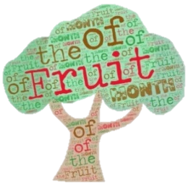
Available Daily:
Locally Grown Fruit
Fruits and Vegetables from the
Farm Stand

