MENDHAM TOWNSHIP
MIDDLE SCHOOL
DECEMBER
2021
MONDAY | TUESDAY | WEDNESDAY | THURSDAY | FRIDAY
 |  | 1  Baked Ravioli w/ Marinara Sauce | 2  All-White Meat Chicken Tenders w/ a Split Top Dinner Roll | 3  Dante’s Pizza
6  Baked Chicken Nuggets w/ a Split Top Dinner Roll | 7  Baked Macaroni & Cheese | 8  Cheese Stuffed Sticks w/ Marinara Sauce | 9  Baked Ziti w/ Marinara Sauce and a Dinner Roll | 10  Dante’s Pizza
13  Pizza Crunchers w/ Marinara Sauce | 14  Popcorn Chicken w/a Split Top Dinner Roll | 15  Pasta w/ Marinara & a Split Top Dinner Roll | 16  Nachos Grande w/ Beef, Cheese, Brown Rice & Scoops | 17  Dante’s Pizza
20  Boneless Chicken Wings w/ a Split Top Dinner Roll | 21  Cheese Lasagna Roll-Up w/ a Split Top Dinner Roll | 22  Baked Macaroni & Cheese | 23  EARLY DISMISSAL  NO LUNCH SERVED | 24  SCHOOL CLOSED
27 | 28 | 29 | 30 | 31
 | 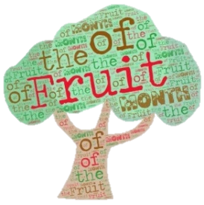  Locally Grown McIntosh Apples | Locally Grown Butternut Squash

Available Daily:
Allergy Aware menus are available for students with food allergies. For more information contact your Food Service Director or see
our Food Allergy Best Practices at www.pomptonian.com.
Fruits and Vegetables from the
Farm Stand
