MENDHAM TOWNSHIP
MIDDLE & ELEMENTARY SCHOOL
AUGUST/SEPTEMBER
2022
MONDAY | TUESDAY | WEDNESDAY | THURSDAY | FRIDAY
 | 23 | 24  Chicken & Waffles Hash Browns  OR  Lasagna w/ Marinara Sauce & a Dinner Roll | 25  All-White Meat Chicken Tenders w/a Split Top Dinner Roll  OR  Lasagna w/ Marinara Sauce & a Dinner Roll | 26  Dante’s Pizza
29  Baked Chicken Nuggets w/ a Split Top Dinner Roll  OR  Mac & Cheese w/ a split top Dinner Roll | 30  Empanadas w/ Sour Cream & Salsa  OR  Mac & Cheese w/ a split top Dinner Roll | 31  Pasta Alfredo w/ Garlic Bread  OR  Mac & Cheese w/ a split top Dinner Roll | 1  Southwest Breaded Chicken Fillet on a Bun  OR  Mac & Cheese w/ a split top Dinner Roll | 2  Dante’s Pizza
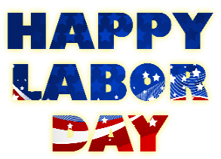  5 | 6  Boneless Chicken Wings w/ a Split Top Dinner Roll  OR  All-Beef Hot Dog on a Bun | 7  Spaghetti w/ Meat Sauce w/ a Split Top Dinner Roll  OR  All-Beef Hot Dog on a Bun | 8  Sweet & Sour Chicken w/ Vegetable Fried Rice & a Fortune Cookie  OR  All-Beef Hot Dog on a Bun | 9  Dante’s Pizza
12  All-White Meat Chicken Tenders w/ a Split Top Dinner Roll  OR  Grilled Cheese Sandwich | 13  Popcorn Chicken Bowl w/ Mashed Potatoes & Corn w/a Dinner Roll  OR  Grilled Cheese Sandwich | 14  3-Cheese Cavatappi w/a Dinner Roll  OR  Grilled Cheese Sandwich | 15  French Toast Sticks w/ Sausage & Tater Tots  OR  Grilled Cheese Sandwich | 16  Dante’s Pizza
19  Popcorn Chicken w/ a Split Top Dinner Roll  OR  Cheese Ravioli w/ Marinara Sauce & a Dinner Roll | 20  Hawaiian Chicken Bite Bowl  OR  Cheese Ravioli w/ Marinara Sauce & a Dinner Roll | 21  Pulled Pork Sandwich  OR  Cheese Ravioli w/ Marinara Sauce & a Dinner Roll | 22  General Tso’s Chicken w/ Vegetable Fried Rice & a Fortune Cookie  OR  Cheese Ravioli w/ Marinara Sauce & a Dinner Roll | 23  Dante’s Pizza
26  ROSH HASHANA  SCHOOL CLOSED | 27  Chicken Potstickers w/ Fried Rice  OR  Cheeseburger w/ Tater Tots | 28  Meatball Parmesan Sub Sandwich  OR  Cheeseburger w/ Tater Tots | 29  Chicken & Waffles w/ Emoji Potatoes  OR  Cheeseburger w/ Tater Tots | 30  Dante’s Pizza
Locally Grown
Vegetable
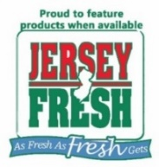
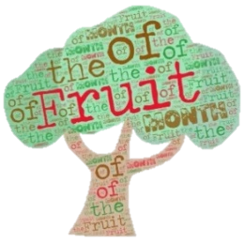
Locally Grown Fruit

