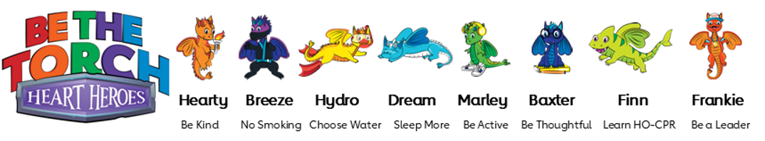
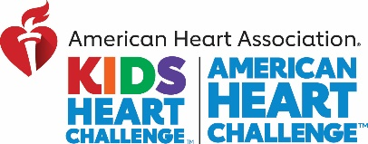

Dear Mendham Twp., Middle School Fifth Grade!
It’s time for our American Heart Association’s Kids Heart Challenge™!
By participating in Kids Heart Challenge, your child can learn about taking care of their hearts and participate in cardio-pumping challenges. They’ll be given a chance to raise awareness and funds to help kids with special hearts and make all communities healthier. They’ll get physical, social, and emotional wellness lessons. Plus, our school can earn NEW Physical Education equipment! ❤ We will be jumping on Tuesday, February 14th.
You can start today to enjoy educational, fun online experiences. Everything can be done easily online with the Kids Heart Challenge app or website.
Here is the link to Mendham Township’s School page:
https://www2.heart.org/site/TR?fr_id=7556&pg=company&company_id=374674
3 Easy STEPS to GET STARTED:
- Download FREE Kids Heart Challenge app or visit www.heart.org/KHC to join our school team & create your own Heart Hero Headquarters! ❤
- Ask your child to select a healthy challenge: Move More or Be Kind. Select the challenge when you register.
- Set out to complete Finn’s Mission and have your family learn Hands Only CPR and the warning signs of a stroke.
WE WILL BE JUMPING IN PE THE WEEK OF FEBRUARY 20TH!

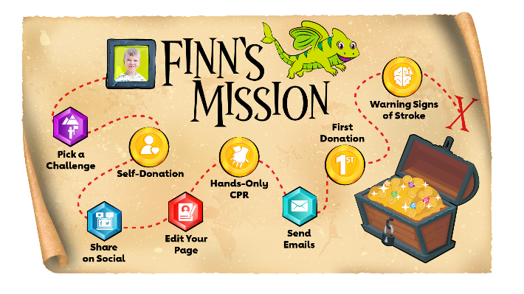
SCAN OUR SCHOOL CODE
Help us get 100% of our school families to learn
Hands-Only CPR!
Finn has worked for years with KHC to help raise awareness and support for kids with special hearts – like him. This year, he set a goal to get 1.8 million families to learn Hands-Only CPR, in honor of the 18 procedures he has had. You can help. Join KHC and take Finn’s Mission to learn this lifesaving skill in under 2- minutes. Your student(s) will earn Finn’s Lifesaver Award when all 8 steps are complete!
